**NPM Installation Guide**

**Table of Contents**

* Accessing NPM software
* Installing Arduino and external libraries
* Uploading and updating software
* Troubleshooting

**Accessing NPM software**

All NPM software is written for Arduino and available at the following GitHub repo: <https://github.com/neurophotometrics/neurophotometrics.git>.

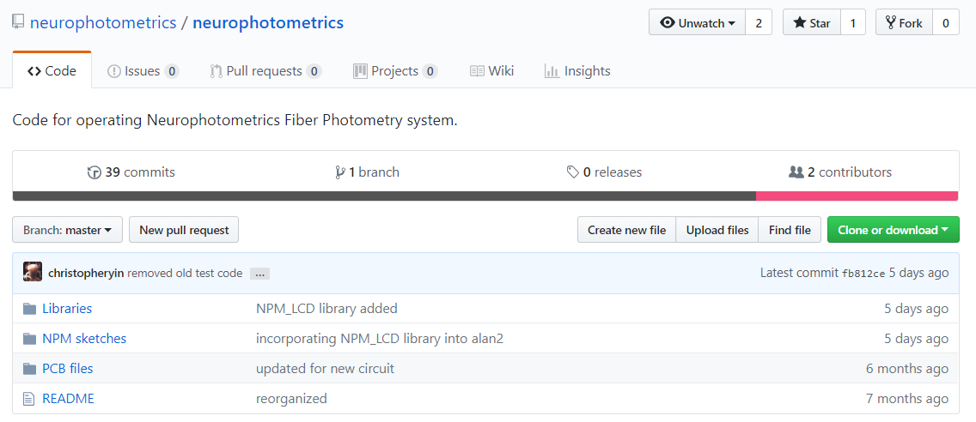

Figure : Cloning or downloading the neurophotometrics GitHub repository.

If you’re familiar with Git already, then clone away. If not, then quick overview: Git is a version control software that allows code to be easily maintained and shared across multiple users. You can download the Git software (<https://git-scm.com/downloads>), or the GitHub GUI for Windows and Mac systems (<https://desktop.github.com/>) using the provided links. If you need help installing or getting started with GitHub, these guides may be useful: <https://help.github.com/desktop/guides/>. If you’re in a hurry and unfamiliar with Git, then you can always directly download the files you need (i.e. library .zip files, Arduino .ino and .h files), but we recommend you use Git for more seamless software updates (plus it’s a great tool in general!). The rest of this guide assumes you’re using Git.

**Installing Arduino and external libraries**

In order to upload code to the driver box, you’ll need to have the Arduino IDE installed. The software can be found at this link: <https://www.arduino.cc/en/Main/Software>.

Once you have the Arduino software installed and the GitHub repo cloned, you’ll need to install two libraries--Button and LiquidCrystal_I2C2004V2. To do so, open an Arduino tab and navigate through the top menu bar to *Sketch > Include Library > Add .ZIP Library*. A file browser will open up; navigate to the *Libraries* folder of the *neurophotometrics* repo on your system and select one of the library .zip files. Repeat this process for the other library.

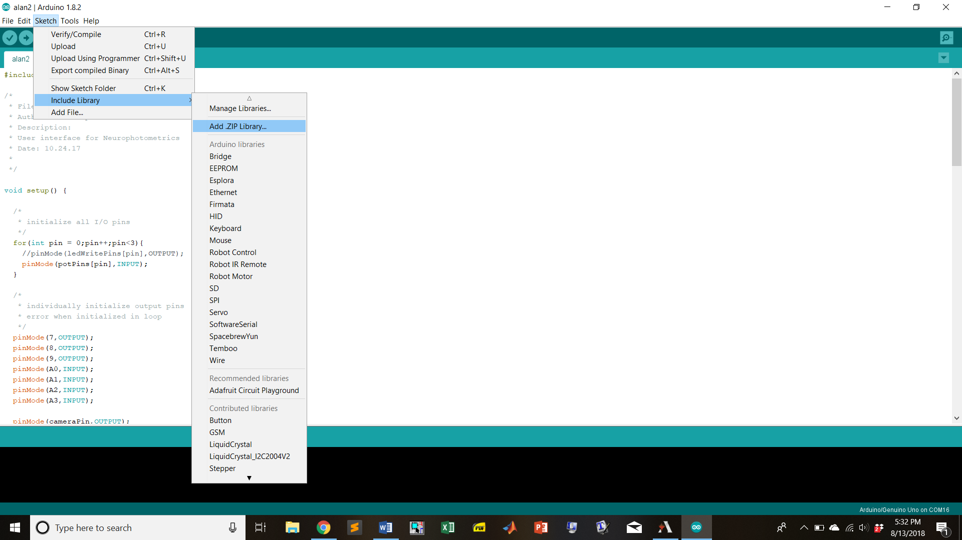

Figure : Including a new, non-default library in your Arduino installation.

The libraries you’ve installed should now show up as available to include, as pictured below. You may need to close out and reopen the Arduino IDE before this change is visible.

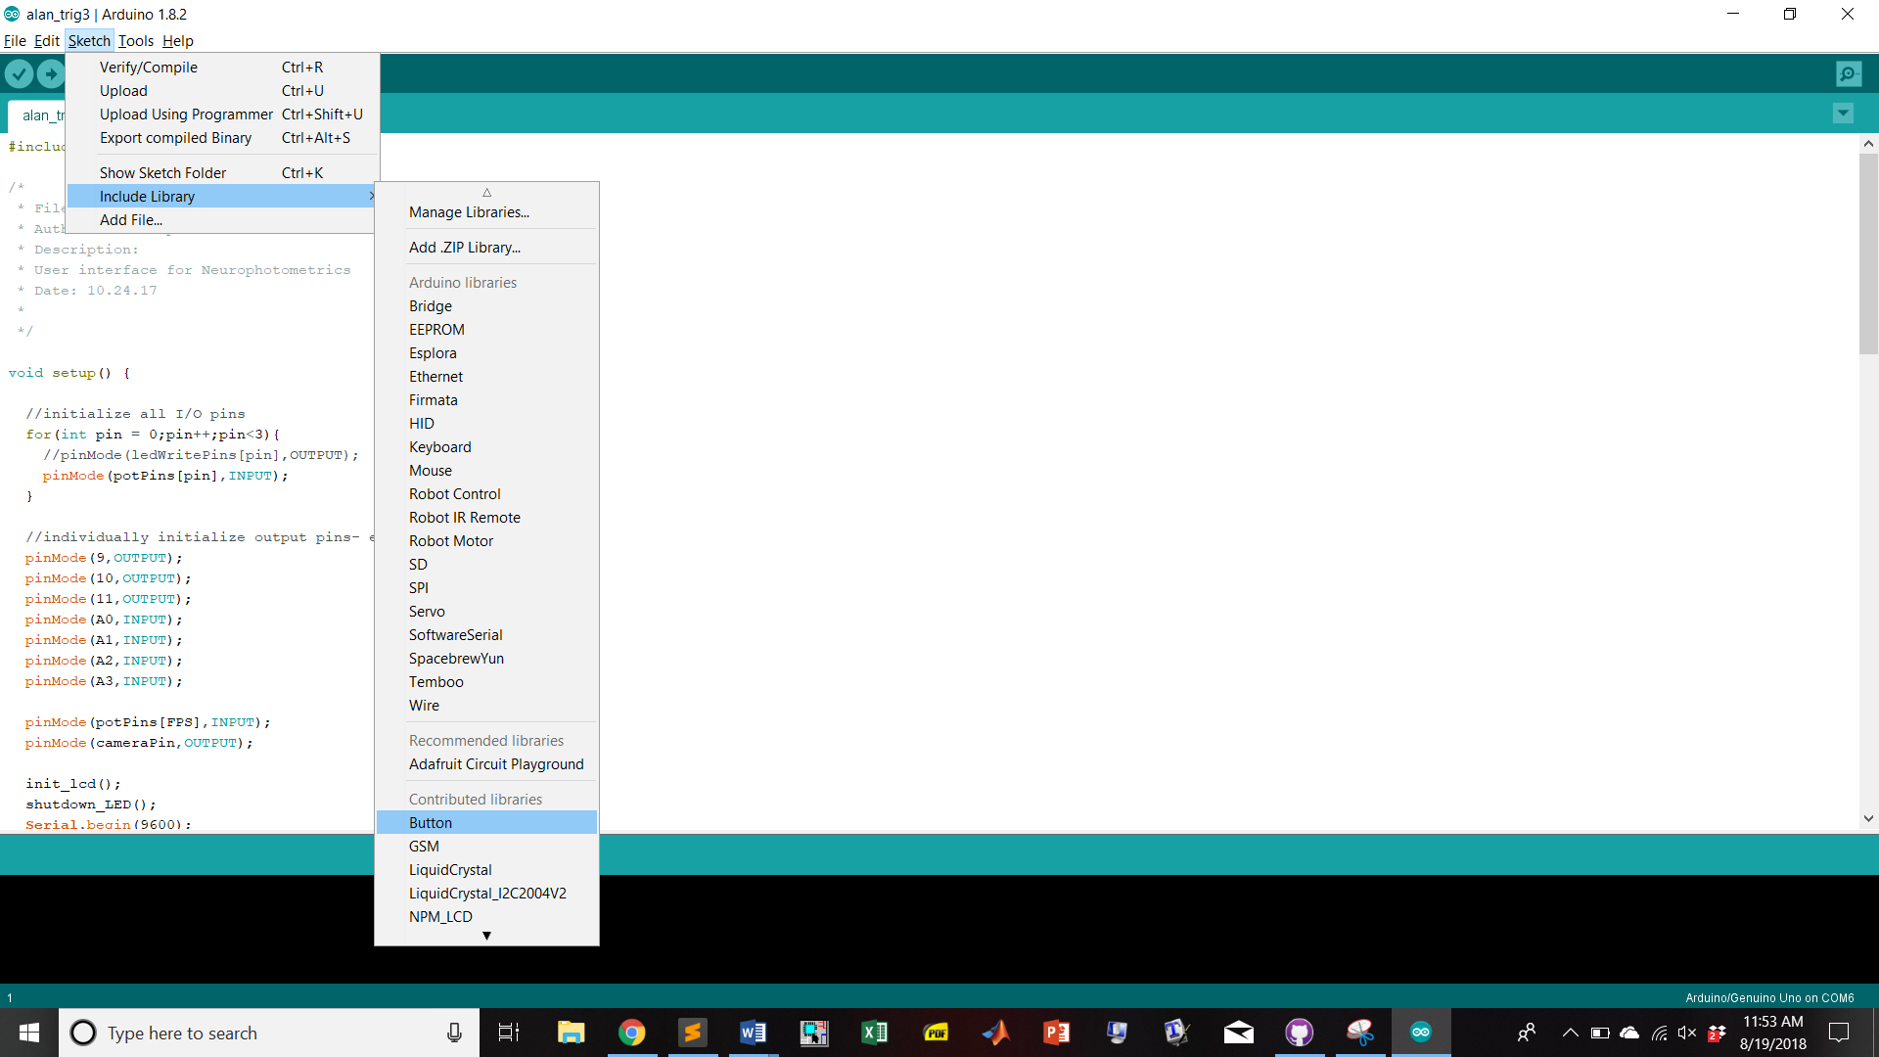

Figure : Libraries successfully installed!

For more information about installing libraries see the Arduino reference: <https://www.arduino.cc/en/Guide/Libraries>.

**Uploading and Updating Software**

The driver box requires both a .ino and a .h file (the former is the Arduino sketch, the latter a header file that contains function definitions and variable declarations and whatnot). Before uploading any code to your driver box you’ll want to have the latest version of the software checked out. If you’re using the GitHub app, click *Fetch Origin* from the top menu bar.

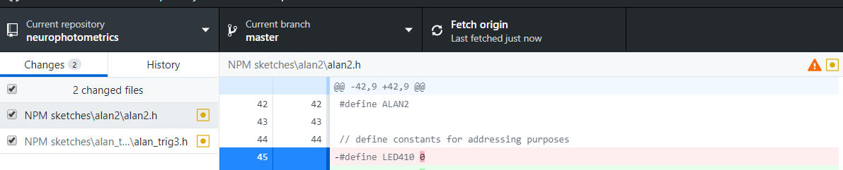

Figure : Updating software to latest version using the Windows GitHub GUI. You’ll want to see “Last fetched just now.”

Navigate to the *NPM Sketches* folder of the neurophotometrics GitHub repo. Select the current software version (most recent is alan2), and select the corresponding .ino file. The Arduino IDE will open on your computer (the header file will open automatically as well). Click the verify button (check mark, pictured below) to ensure the code compiles. If not, check the errors reported at the bottom of the IDE--it’s likely the libraries weren’t installed properly, and you may need to try again.



Figure : Verifying your Arduino code compiles (e.g. no stray syntax errors, library not installed correctly)

Once you’ve verified the code compiles on your system, you can upload it to the driver box. Using the provided cable, connect a USB port on your computer to the USB B receptacle on the driver box. Navigate to *Tools > Port* on the top menu bar and ensure a port is selected. Confirm that under *Tools > Board* you have “Arduino/Genuino Uno” selected. Finally, click the upload button (horizontal arrow, pictured below) to upload the software to the driver box.



Figure : Uploading software to your driver box.

If you receive an error, you may need to select another Port from the *Tools > Port* menu. Otherwise, you should be all set to science!

**Troubleshooting**

*The LCD screen on my driver box lights up but only displays solid boxes*.

The driver box ships with one of two LCD models--your current software is writing to the wrong address. Find the following line of code in the appropriate alan_.h file that looks like this:

LiquidCrystal_I2C lcd(0x3F,20,4);

Change the first argument from 0x3F to 0x27, or vice versa, and re-upload the code.

*Anything else*

Sacrifice a newborn lamb with a silver blade at midnight beneath a full moon, pour its blood into a stone chalice and whisper “Wake, Cthulu” three times, let your mind dissolve into the glorious ecstasy of ineffable oblivion, having been assured that nothing matters anymore and we have been but a brief dream in the lightless minds of the infinite.